CMPS 350 Project Phase 1 – Report
Education Platform
(10% of the course grade)
The report must be submitted in Word format only
Group Members | Ameen Mansour 202207848 am2207848@qu.edu.qa  Mohammed Sherin Valiyakath 202212598 mv2212598@qu.edu.qa  Mishal Ashraf 202308960 ma2308960@qu.edu.qa  Aman Mohammed 202309156 am2309156@qu.edu.qa
GitHub link | https://github.com/mdsherinoff/cmps350-project

Grades :
The student fills only the “Implementation Percentage”: Please specify either: Working (completed x%), Not Working (completed x%) or Not done.
Criteria | Points | Implementation Percentage | Implementation Quality | Your Grade
Design and implement the app Web UI and navigation using HTML, CSS and JavaScript. Including designing the App Web UI and navigation. | 50
Design and implement the Web API and data access repositories to read/write the app data JSON files. | 30
Application modeling (e.g. UML diagrams) to explain the data entities and the functionalities | 5
Testing documentation using screen shots illustrating the testing results. | 5
Team work quality. Contributions of team members - All members should collaborate and contribute equally to the project. | 5
Project report – description of the implemented app, what is implemented, what is missed .. | 5
Total | 100
Plagiarism, outsourcing, free riders | -100
Delivery behind the deadline | -5

Important remark: In case of copying and/or plagiarism or not being able to explain or answer questions about the implementation, you lose the whole grade.
* Criteria for grading the functionality:
- The functionality is working: you get 70% of the assigned grade.
- The functionality is not working: you lose 40% of assigned grade.
- The functionality is not implemented: you get 0.
- The remaining grade in all cases from above is assigned to the quality of the implementation,
- The grades are distributed on the various use cases, when the design/implementation is partial, you get only the grades of designed/implemented use cases.

Code quality criteria, include:
- Use of meaningful identifiers for variables and functions (e.g. using JavaScript naming conventions)
- Pages are responsive
- Clean code: simple and concise code, no redundancy
- Clean implementation without unnecessary files/code
- Use of comments where necessary
- Proper code formatting and indentation.

You lose marks for code duplication, poor/inefficient coding practices, poor naming of identifiers, unclean/untidy submission, and unnecessary complex/poor user interface design.

Important Remark:
[Grades: 100-85]: Will be given only to fully functional application with all the quality criteria cited above met and the project has excellent design for the various functionalities. The report is professional.
[Grades: 85-80]: Will be given only to functional application with most of all the quality criteria cited above met and the project has good design for the various functionalities. The report is professional.
[Grades: 80-75]: 80% of the application functionalities are functional. The project respects partially the quality criteria. The report is professional but misses some information.
The grades are not negotiable. We expect that only a small portion (around 15%) of the class will be able to meet the criteria for the grades [100-85]. You should work hard to and demonstrate the merits of your application to earn those grades.+

Description of your proposed platform

A login system comprising of a negligibly minimalistic design of a gradient color theme attempts to take in user information, divided into a student, an instructor, and a departmental admin. Each login takes the user to their respective pages, where the student can view and register for courses with specific sections enabled, while at the same time note down his/her learning path to be followed to complete his degree. It also displays the varying grades and courses in progress.

An instructor is able to picture the prospective courses he must undertake and envision the grading mechanisms to be assigned to the students for the courses he teaches. The admin is given the authorization to manage classes and validate courses to be open for registration. He also has the authority to create newer classes and sections. While at the same time view the schedule of courses in progress.

Application Design

Use case diagram

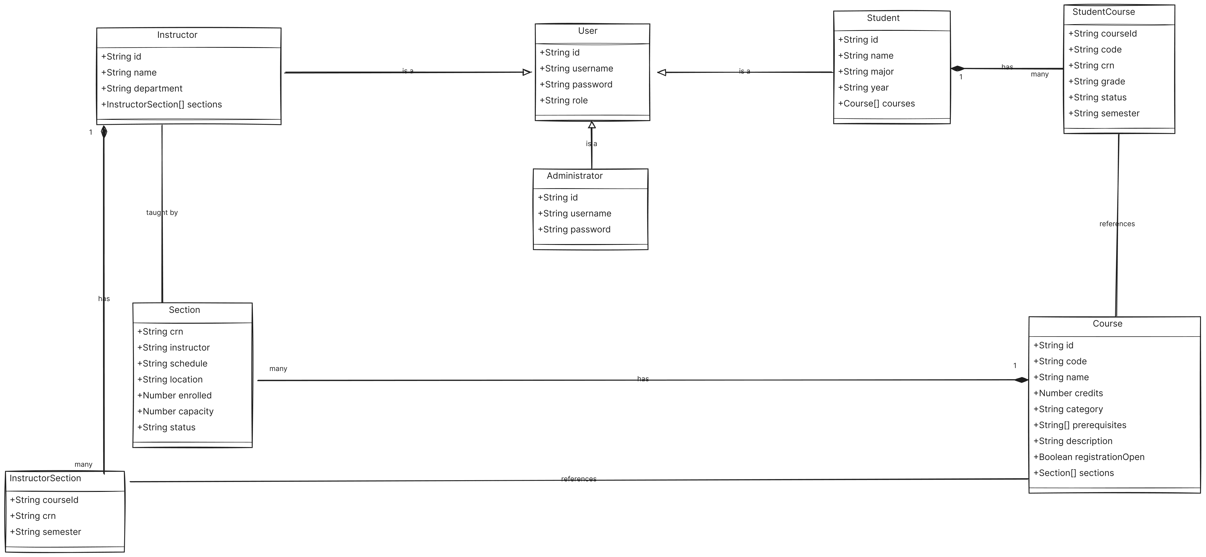
Entities class diagram

Web API class
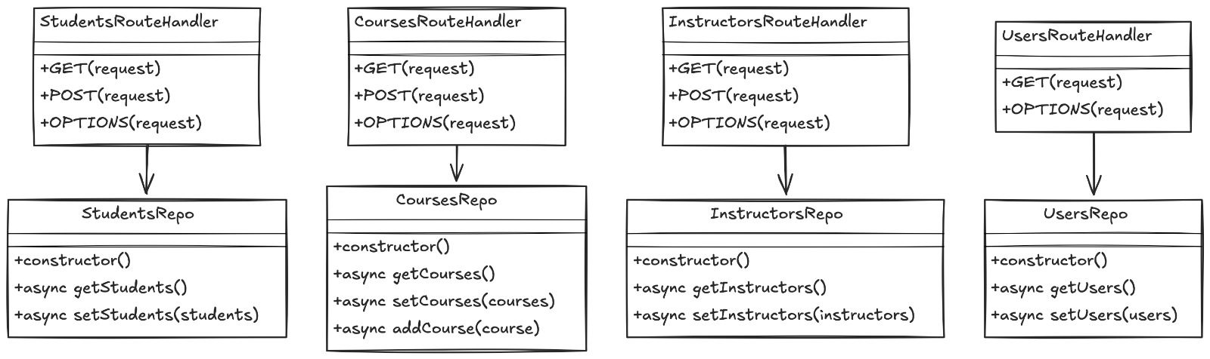

Implementation

Implemented use-cases
The use-cases from 1 through 6 and use case 8 was taken up by the team. Use case 1 focuses on the login page, with use case 2 to 4 prioritizing the student page lineups. The use-case 5 and 8 protrudes into the admin setup, and is topped up on use-case 6 as an extension of instructor.

Unimplemented use-cases and not functioning parts
The HTML color code assumes a natural melodious scheme which is entertainingly complimented by the alignment of sections and divisions of code. The user interface is very friendly and easy to follow, with proper support in every department. The code is completely commented to understand various parts of the document.

Testing

Use case 1
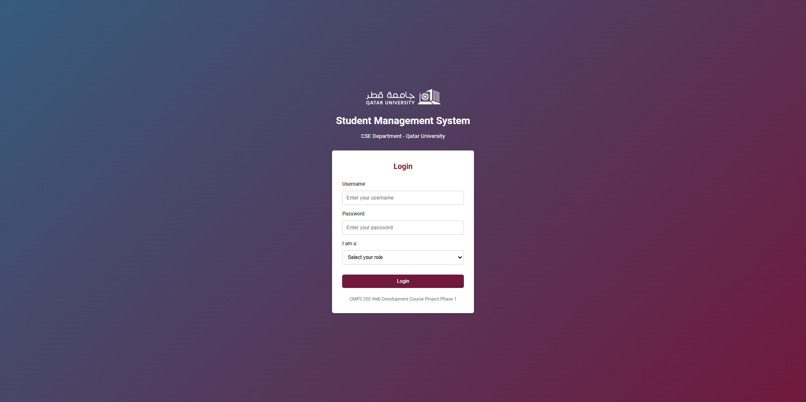
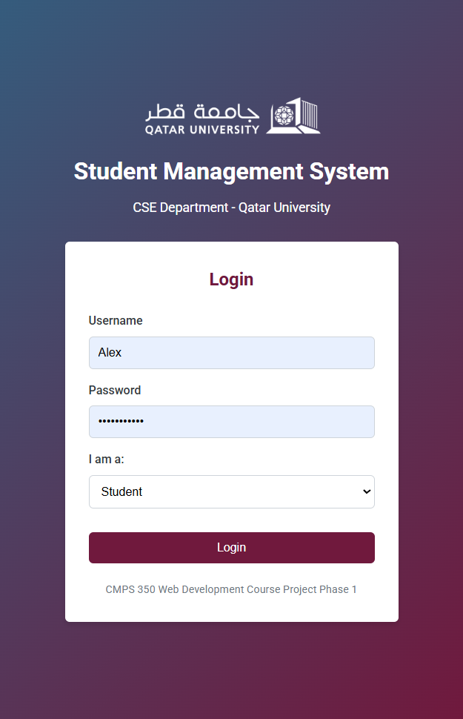
A login page culminating the vibrance of emotional intelligence and melodious decency, the login page gives a distinct approach that targets the pathos of the user to start off the interface in good moods. The login, divided into three sections takes in the Username, the Password and the role of the user and proceeds to redirect to their respective pages.

Use case 2
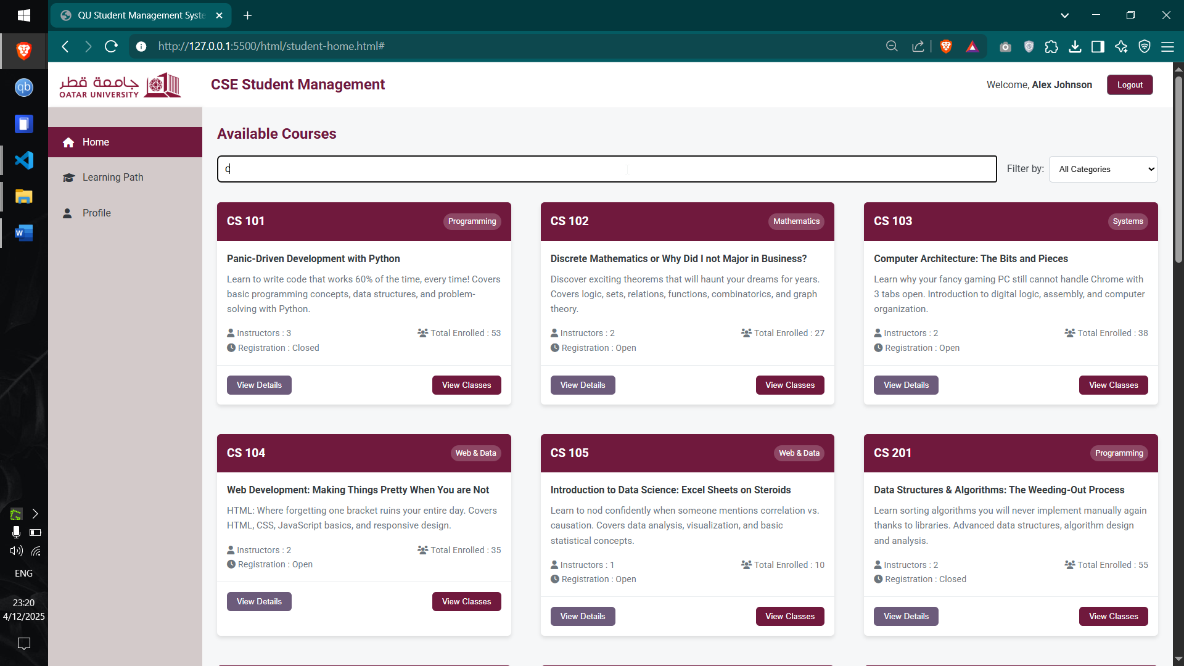

With the search bar appearing as a placeholder to search specific courses, and a filter to filter out necessary items pertaining to the users needs, interface simplification and efficient minimalization is thus achieved.

Use case 3
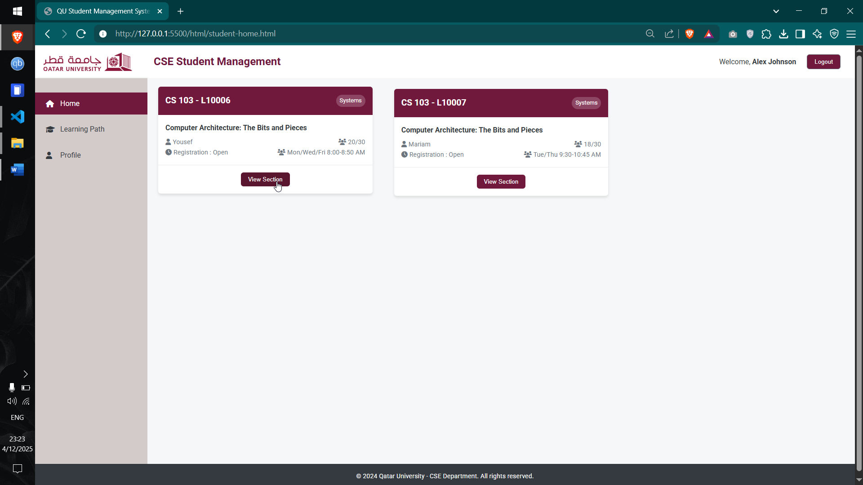
The user is able to view specific sections in a course, and register for it. This is essentially confirmed by the system and thus added into the learning path for easier access.

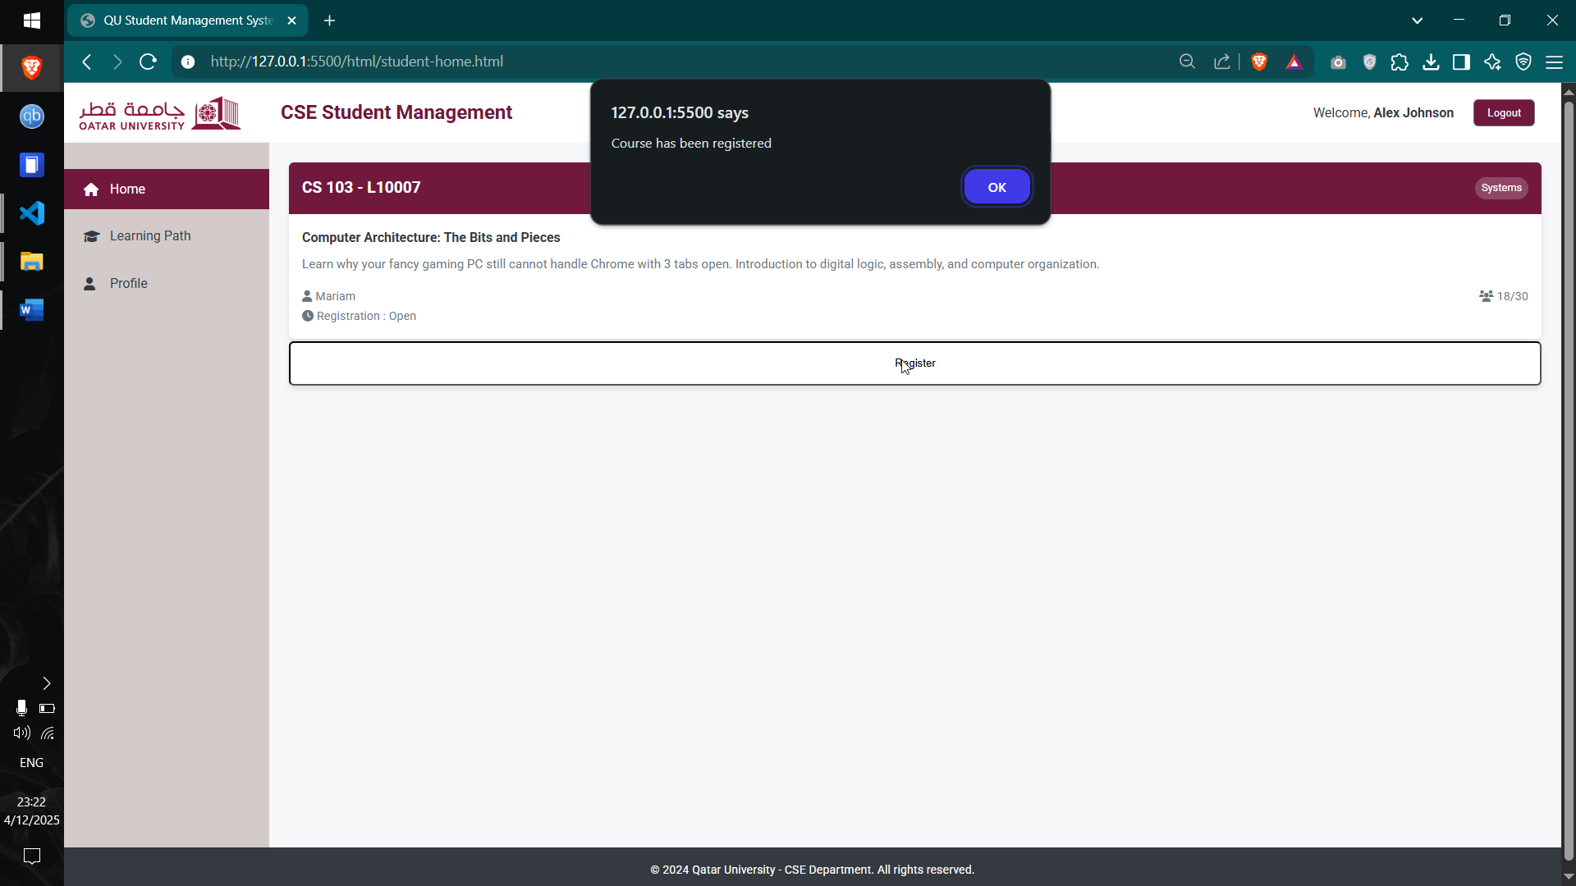

Use case 4
The learning path involves showing all necessary courses to be completed in order to complete the degree. The legend displays the color projections over the courses. This is followed by a Progress checker and current semester outlook, while at the same time displaying the courses which are pending.

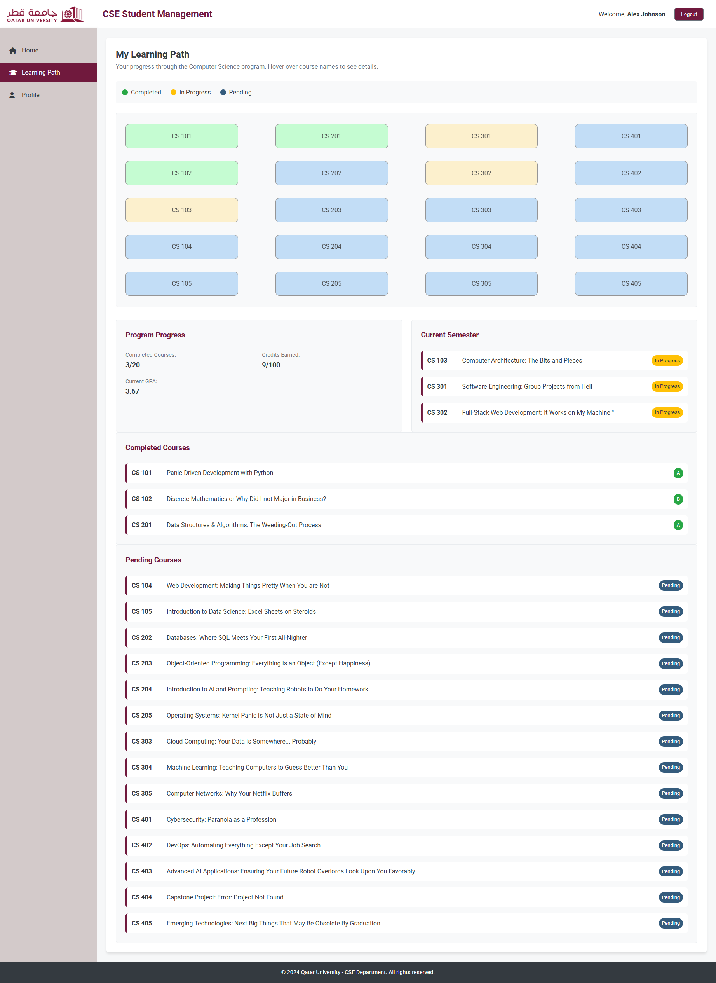

Use case 5
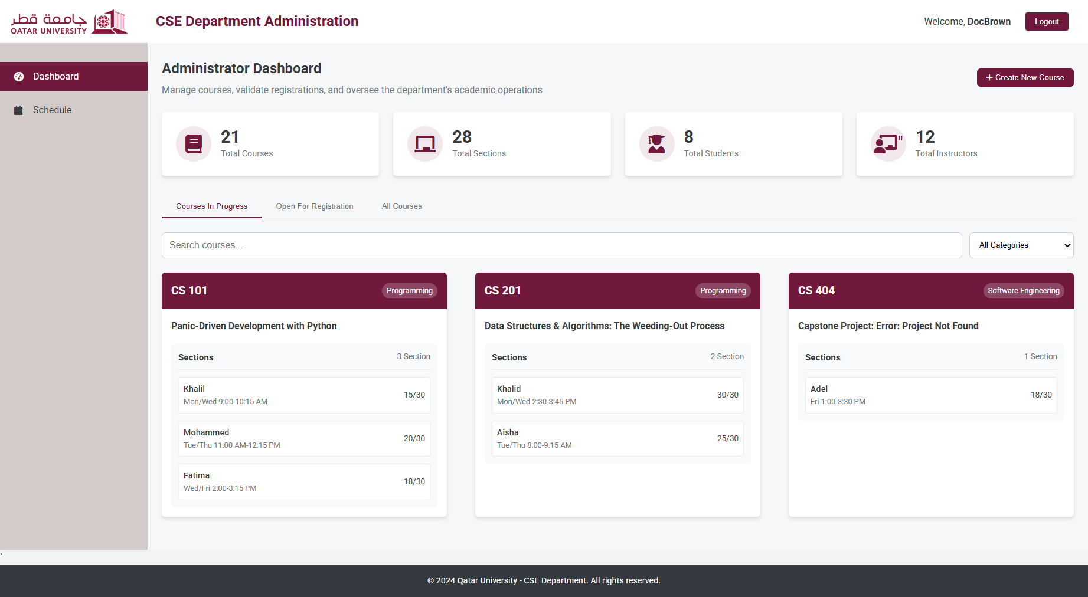

The admin has the ability to view the courses currently in progress, the ones open for registration, and all the courses which can be validated to open specific courses to be started.

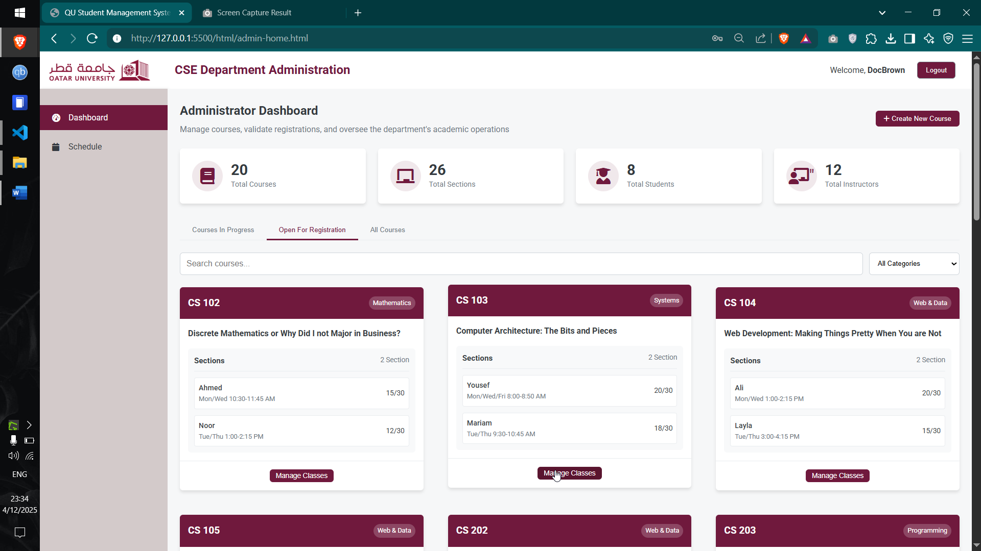

This is also followed by the ability to create new classes and sections.

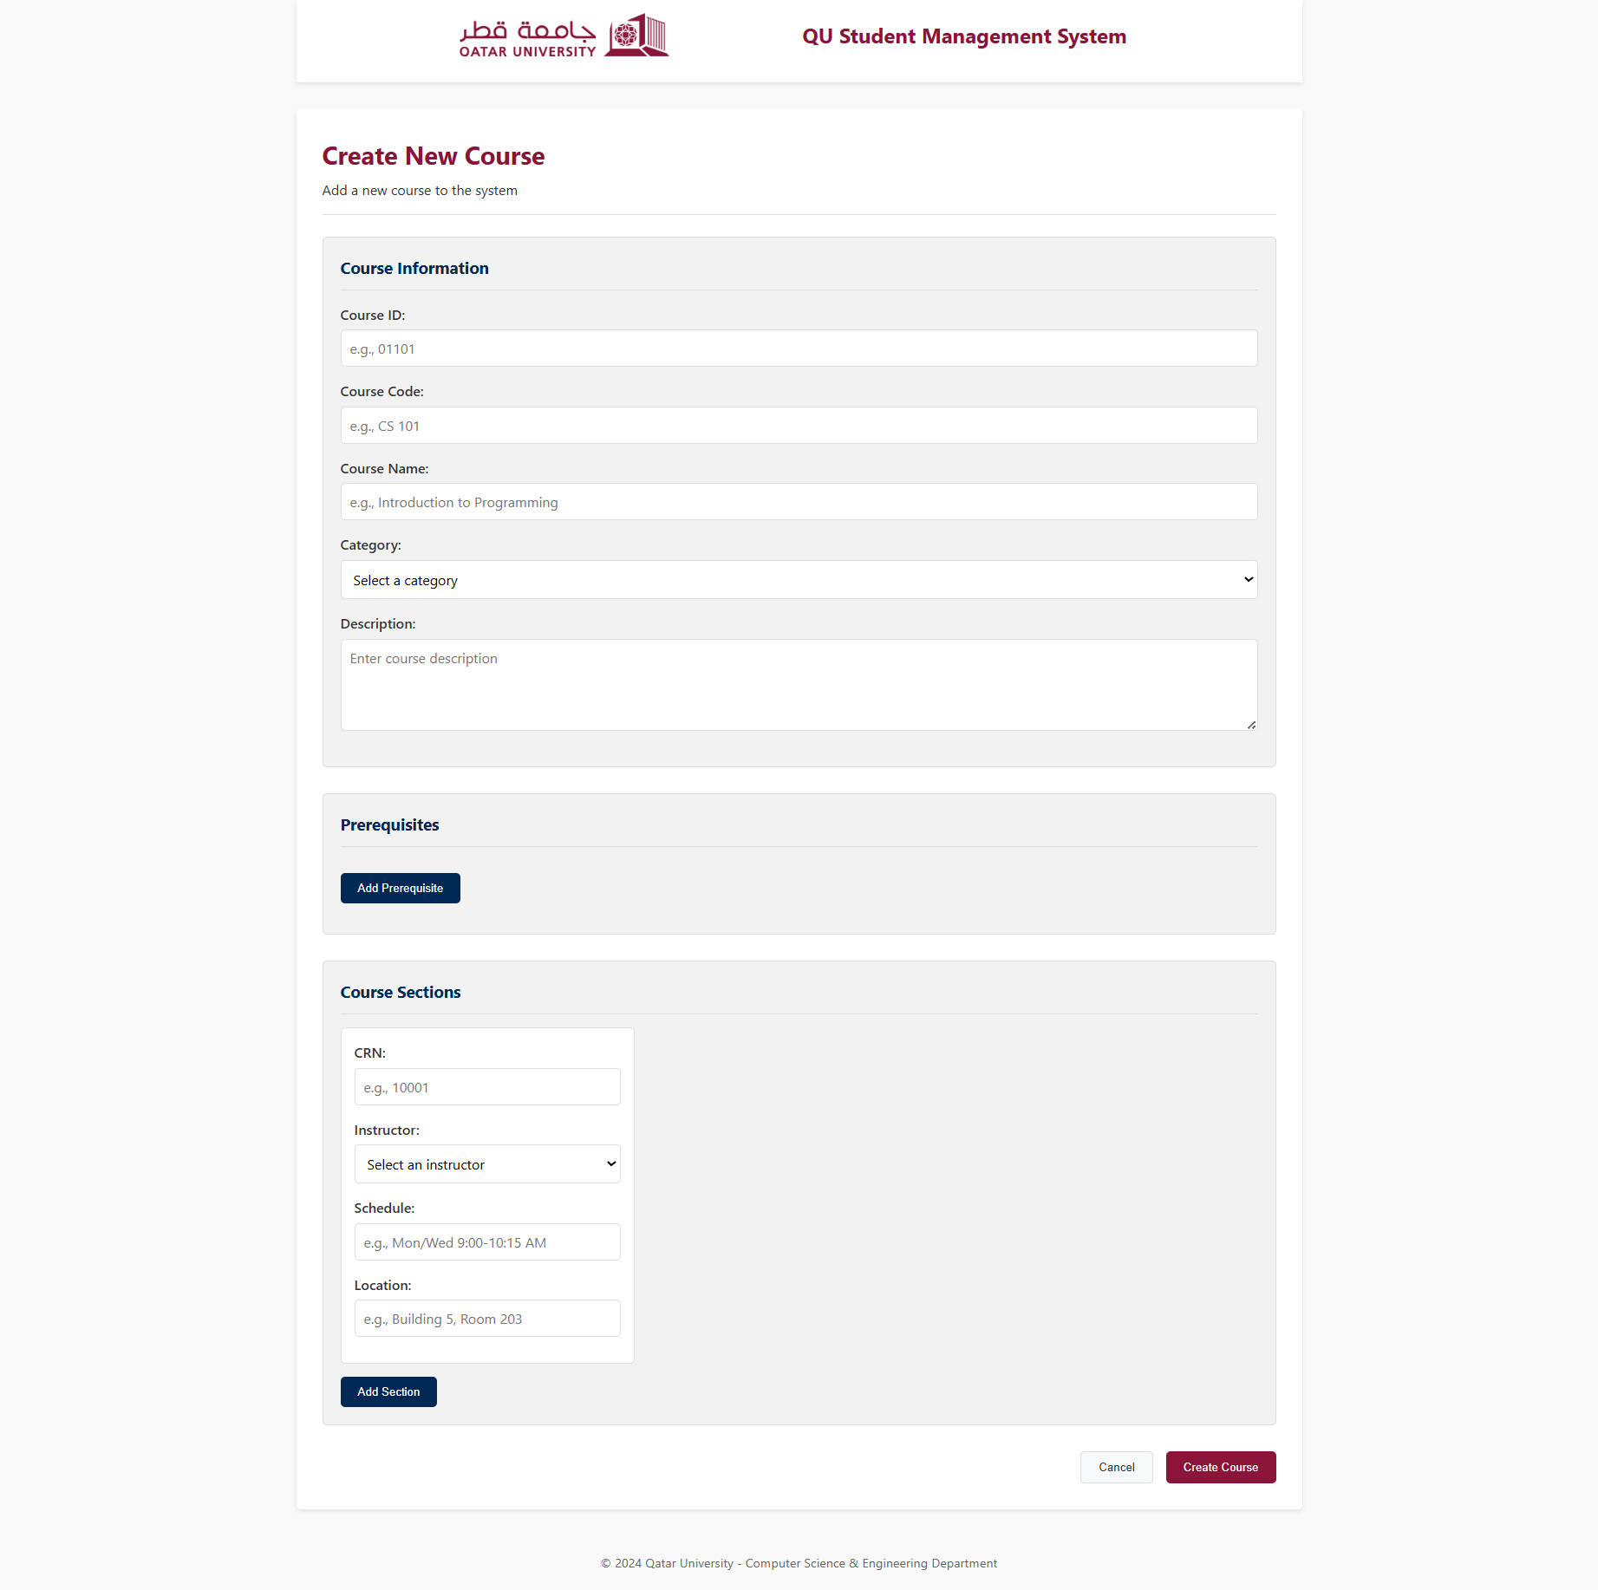

Use case 6
The instructor page displays a distinctive dashboard, complete with stats based on classes undertaken, alongside the different courses students have registered for wherein they can be graded.
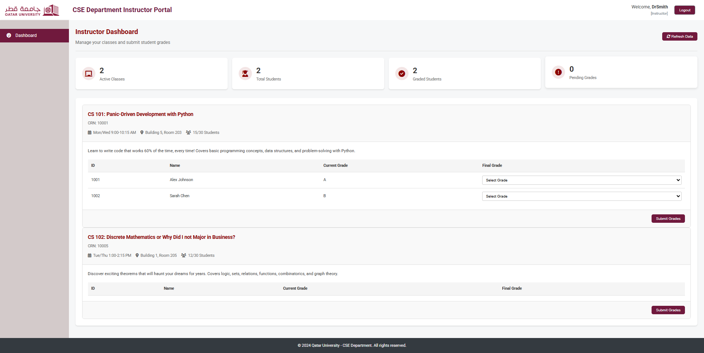

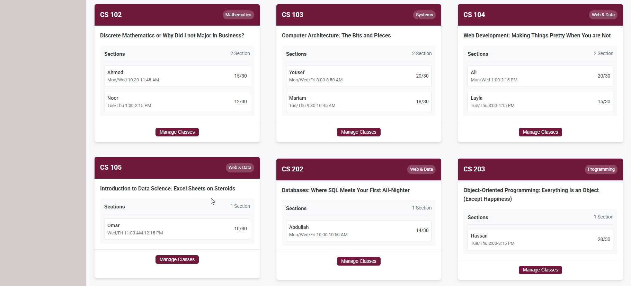
Use case 8
This page allows the admin to view the courses currently in progress, and filter according to his/her needs.
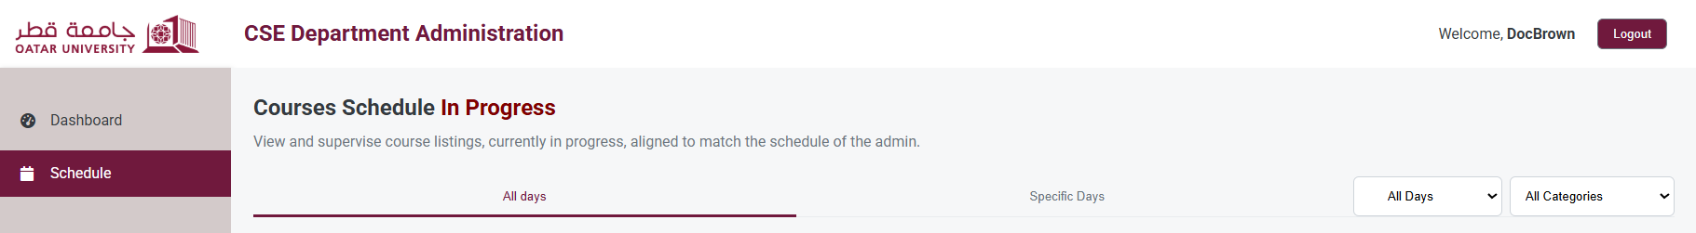

Discussion of the project contribution of each team member

Ameen Mansour | 15%
Mohammed Sherin Valiyakath | 30%
Mishal Ashraf | 30%
Aman Mohammed | 25%

With Sherin and Mishal assuming responsibility for Case 1 through 4 respectively, Aman decided to take Case 5 and 6 into his own hands. Ameen was thus left with the tasks of Case 8, and also provided the HTML and CSS development.

Sherin and Mishal collaborated to focus on the login page, and major parts of the student page alongside the learning path within the student home. Aman developed the instructor page and the dashboard ideas, and contributed positively to the admin page onlook. Ameen was responsible for the touchups in every page, alongside the HTML and CSS designing while also proofreading the entire document with the team.

